Deep Learning Lab

Name:Y.C.Thejaswini

Reg No:19MAI0022

RNN:

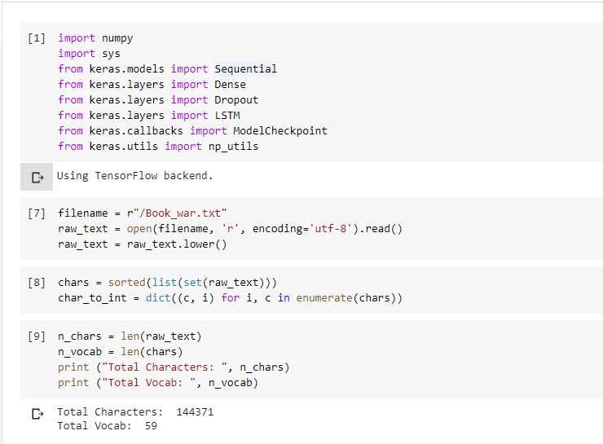

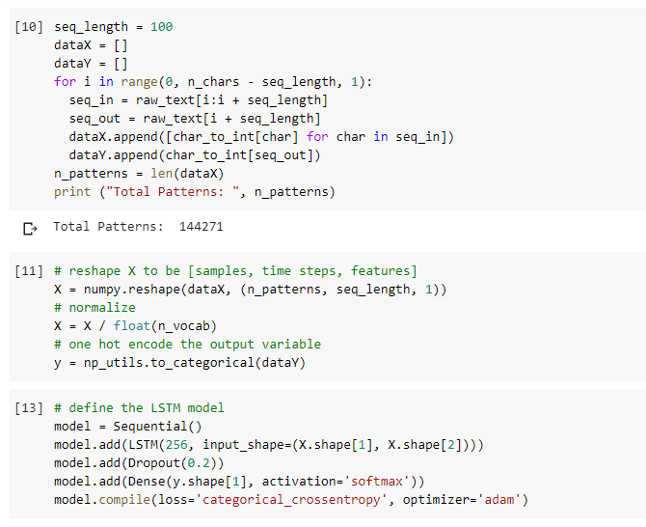

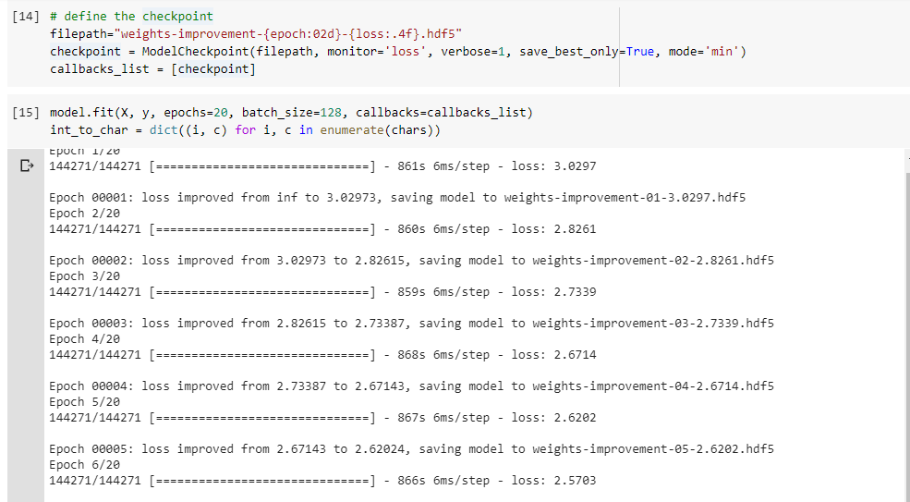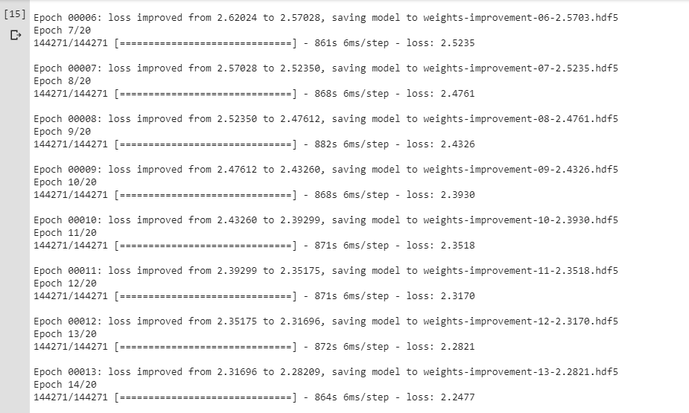

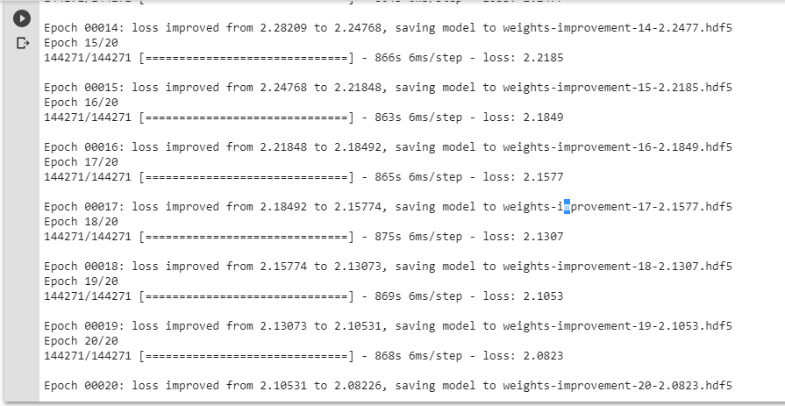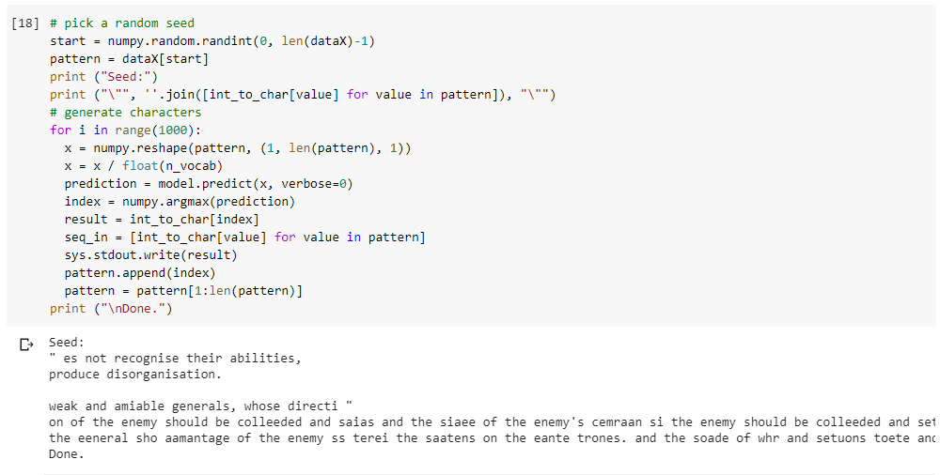

Github link: <https://github.com/thejaswini-yc/CSE6037-Deep-Learning-/blob/master/recurrent%20nn.ipynb>